
SECRET
FUNCTION INTRODUCTION
Function management
Function Name: |  | Electronic Stability Control
Function Mapping: |  | Driver assistance, autonomous driving, and chassis management
Function: |  |  |  | Function-ID:
 | Name |  | Roler | Date | signature
Create/Modify:
check:
Approve OMK:

1 Function Introduction 3
1.1 Function description 3
1.2 Function partner list 3
1.3 Function action mode diagram 4
2 System Architecture 5
2.1 Function architecture 5
2.2 Sub-function list 5
2.3 Description of function interface 6
3 Basis function specificaiton 7
3.1 Description of the function status 7
3.2 Logical signals of function 8
3.3 Base Parameters of function 9
3.4 State interpretation and diagram 10
3.5 Diagnostic requirement 10
4 Major Additional Function 11
4.1 Active Roll Mitigation 11
5 Special States Detect 12
5.1 Specific driving scenarios detection 13
5.2 Performance Mode 13
6 Functional safty 13
6.1 Hazard and Risk analysis 13
6.2 Functional safety concept 13
7 Regulatory Requirements 13
8 Function Dependencies 14
8.1 Internal 14
8.2 Extra 14
8.3 Self-checking strategy...........................................................................................................................15
9 Special Performance Requirements 16
10 Appendix A 17
10.1 Change History 17

Function Introduction

Function description
ESC (Electronic Stability Control) is an active safety system. It can be used interchangeably with
VDC,VSC,AYC. The intent of this subsystem is to prevent your vehicle from deviating from the intended path of the driver when the car is rotating in some fashion. This rotation can come from the driver’s steering wheel inputs, road conditions (curvature and banking), throttle input or brake input.
Sometimes, for whatever reason, the vehicles’ actual path does not match the path that the driver
intends, which results in a loss of vehicle control to a large or a small degree. When the ESC system activates, it selectively applies brake pressure to one or more wheels at a time to cause the car to rotate and steer along the intended path of travel.
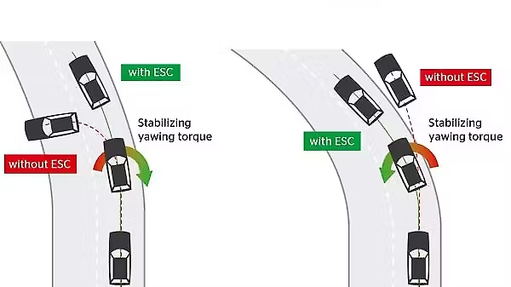
Figure1. Comparison with or without ESC

Electronic Stability Control is designed to assist the driver in critical driving situations. Entering a bend too quickly, rapid change of surface adhesion or a suddenly occurring obstacle are still dangerous driving situations, but ESC makes vehicle reaction predictable and easier to handle.

Function partner list
- iBRS
- IMU
- ESC switch
- Wheel Speed Sensor
- LDCU
- EPS

Function action mode diagram
ESC is used to correct for oversteer and understeer situations. Below is an illustration of
oversteer and understeer with the results.
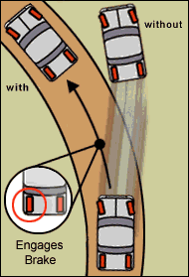
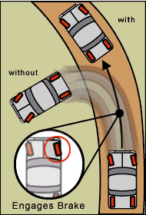

Oversteer ESC Control Understeer ESC Control
Figure2. ESC functions control strategy

For the hydraulic unit, the system build the pressure to control the specific wheel as the request.
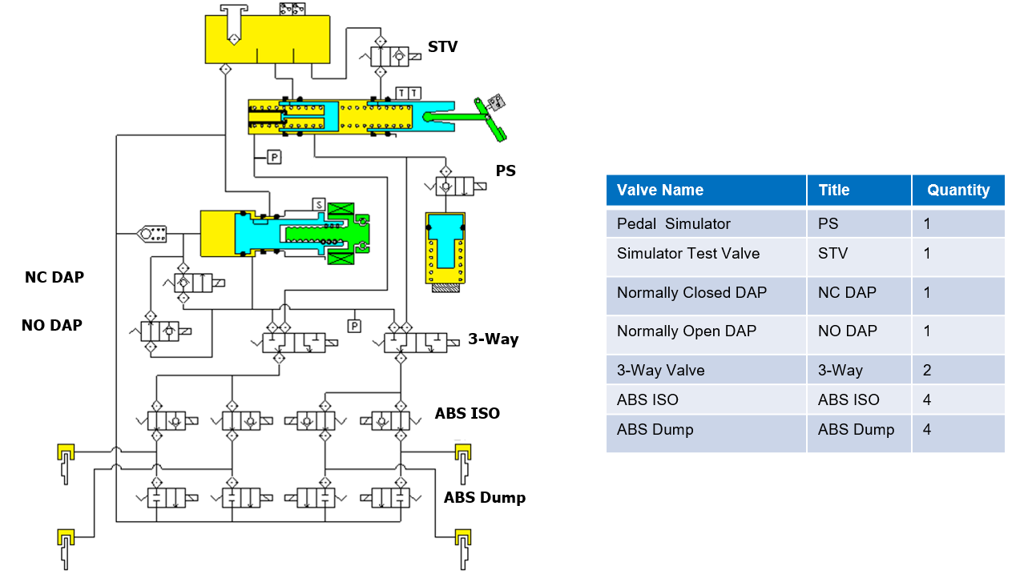
Figure3. Hydraulic Schematic

System Architecture

Function architecture
ESC controls mainly the vehicle lateral dynamics. This is done by comparing the desired vehicle
motion (driver demand) to the actual vehicle motion. Therefore ESC needs additional sensor
information of yaw rate, lateral acceleration, steering angle and pressure sensor.
Whenever ESC becomes active it will control the vehicle motion in a way to best follow drivers
demand within the restrictions of physics. This can be reached via the interfaces to engine
and/or brake actuator.
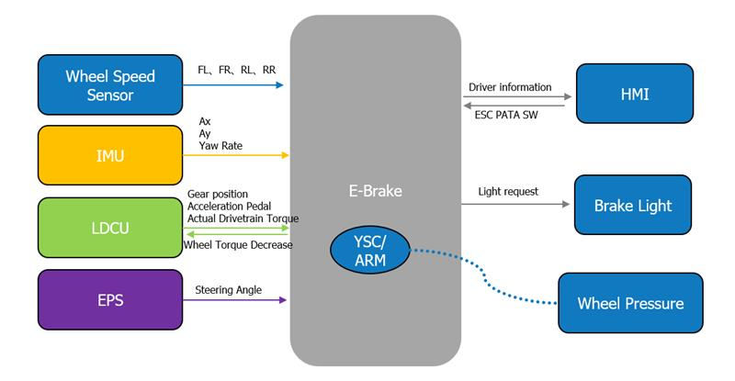
Figure 4. ESC system architecture

Sub-function list
The ESC subsystem includes the below features that will be discussed in this document, but it
can be reduced at the highest level into four separate slip control sub-functions listed as follows:
- Oversteer control
- Understeer control

Description of function interface

System dependency (Signals Interaction)
The following table lists the interactive signals for ESC function. The names in the table are from VW CMP21D CEA Comms matrix “VW_CMP21D_CAN_MATRIX20250414 ”.
Signal Name | Sender | Tx/Rx | Cycle | Unit | Range | ASIL Level | Description
LDCU_AccPedalSig | LDCU | Rx | 10ms | % | 0-100 | ASIL C | Accelerator pedal position signal
LDCU_AccPedalSigVD | LDCU | Rx | 10ms | Enum | 0x0:Not valid;  0x1:Valid; | ASIL C | LDCU_Accelerate Pedal Signal Valid
CDCU_ESC_PATASw | CDCU | Rx | 100ms | Enum | 0x0:No command;  0x1:Normal;  0x2:Sport;  0x3:Off; | QM | ESC_OFF SW
IPB_VehLongAccel | IMU | Rx(Private) | 10ms | g | -1.73 – 1.73 | ASIL B (D) | Longitudinal Acceleration
IPB_VehLongAccelVD | IMU | Rx(Private) | 10ms | Enum | 0x0:Not valid;  0x1:valid; | ASIL B (D) | The valid of longitudinal acceleration
IPB_VehLateralAccel | IMU | Rx(Private) | 10ms | g | -1.73 – 1.73 | ASIL B (D) | Lateral Acceleration
IPB_VehLateralAccelVD | IMU | Rx(Private) | 10ms | Enum | 0x0:Not valid;  0x1:valid; | ASIL B (D) | The valid of lateral acceleration
IPB_YAWRate | IMU | Rx(Private) | 10ms | degps | -93 - 93 | ASIL B (D) | Yaw Rate
IPB_YAWRateVD | IMU | Rx(Private) | 10ms | Enum | 0x0:Not valid;  0x1:valid; | ASIL B (D) | The valid of YawRate
EPS_SteeringAngle | EPS | Rx | 10ms | deg | -780-779.9 | ASIL B | Steering Angle
EPS_SteeringAngleVD | EPS | Rx | 10ms | Boolean | 0x0:Not Valid;  0x1:Valid; | ASIL B | The valid of Steering Angle
LDCU_RWheelCurTorq | LDCU | Rx | 10ms | Nm | -6000 - 6000 | ASIL B | LDCU_Rear Wheel Peak Torque Maximum
LDCU_FWheelCurTorq | LDCU | Rx | 10ms | Nm | -6000 - 6000 | ASIL B | LDCU_Front Wheel Peak Torque Minimun
LDCU_RWheelDriverTorqReq | LDCU | Rx | 10ms | Nm | -6000 - 6000 | ASIL C | LDCU_Rear Wheel Driver Torque Request
LDCU_FWheelDriverTorqReq | LDCU | Rx | 10ms | Nm | -6000 - 6000 | ASIL C | LDCU_Front Wheel Driver Torque Request
LDCU_GearLev | LDCU | Rx | 10ms | Enum | 0x0:Invalid;  0x1:D gear;  0x2:N gear;  0x3:Rgear;  0x4:P gear;  0x5-0x7:Reserved | ASIL B | LDCU_Gear Level
IPB_VDCActSt | iBRS | Tx | 20ms | Enum | 0x0:Not active;  0x1:active; | ASIL B | Indicates VDC in active or not
IPB_ESPFault | iBRS | Tx | 20ms | Enum | 0x0:Not fault;  0x1:Fault; | ASIL B | IPB_ESP Fault
IPB_ARPActSt | iBRS | Tx | 20ms | Enum | 0x0:Not active;  0x1:Active; | ASIL B | Indication that EBP system currently performs a brake intervention
IPB_LDCU_RWheelTorqDecFast | iBRS | Tx | 10ms | Nm | -6000 - 6000 | ASIL C (D) | This torque is VCU combustion(indicated) decreased target torque (fast)
IPB_LDCU_FWheelTorqDecFast | iBRS | Tx | 10ms | Nm | -6000 - 6000 | ASIL C (D) | This torque is VCU combustion(indicated) decreased target torque (fast)
IPB_BrkLightOnReq | iBRS | Tx | 20ms | Boolean | 0x0:Off;  0x1:On; | ASIL B | Break Light On Request
IPB_BrkLightOnReq_E2E | iBRS | Tx | 20ms | Boolean | 0x0:Off;  0x1:On; | ASIL B | Break Light On Request,E2E

Hardware Interface
Name | Type
KL15 | Hardwired
KL30 | Hardwired
Left front wheel speed sensor | intelligent
Right front wheel speed sensor | intelligent
Left rear wheel speed sensor | intelligent
Right rear wheel speed sensor | intelligent
IPB CAN(H、L) | Hardwired

Basis function specification

Description of the function status
ESC system that uses independent brake and powertrain control to keep the vehicle as close to its intended path as possible, as dictated by sensor inputs from steering angle, vehicle yaw, vehicle lateral acceleration, and a master cylinder pressure sensor.
As shown in the pictures, oversteer (also known as fishtailing, skidding or spinning out) happens when the vehicle rotates more than the driver intends it to.
Understeer (also known as plowing or pushing) happens when the driver turn the wheel and the car
does not turn as much as the driver would like.
To correct for Oversteer, ESC applies pressure to the outside wheels. If you are negotiating a Left-hand turn and the car starts spinning out, the ESC would apply brake pressure to the right front
to bring the car back on path.

Left turn& Oversteer:
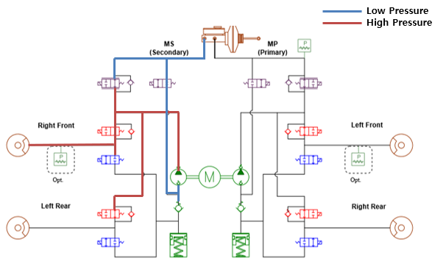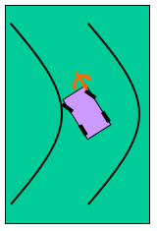

Conversely, for Understeer, ESC applies pressure to the inside rear wheel to force the car to rotate
about the center of gravity and to turn the vehicle

Left turn &Understeer:
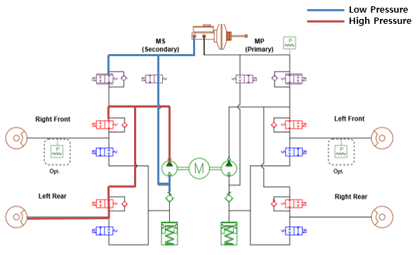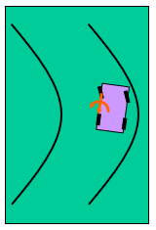
Figure 5. ESC Schematic Diagram Of The Work

Logical signals of function
The conditions of ESC enable and activation should meet the following conditions:

- The enable conditions of ESC function:
- The feature is not degraded by fault
And
- Roller bench mode is inactive
And
- LDCU_EVSysReadySt is ready
- The disable conditions of ESC function:
- The feature is degraded by fault
OR
- Roller bench mode is active
OR
- LDCU_EVSysReadySt is not ready

- The activation conditions of ESC function:
- Driving Mode is not switched to ESC OFF
And
- Vehicle speed is above the threshold TBD1
And
- Driving direction is forward
And
- The deviation between driver intended yaw rate and vehicle yaw rate is greater than the threshold TBD2 (OS) OR The deviation between driver intended yaw rate and vehicle yaw rate is greater than vehicle understeer yaw rate threshold TBD3 (US)

- The deactivation conditions of ESC function:
- Driving Mode is switched to ESC OFF
OR
- Vehicle speed is below the threshold TBD4
OR
- Driving direction is not forward
OR
- The deviation between driver intended yaw rate and vehicle yaw rate is not greater than the threshold TBD5 (OS) AND The deviation between driver intended yaw rate and vehicle yaw rate is not greater than vehicle understeer yaw rate threshold TBD6 (US)

Base Parameters of function
This table defines the required basic threshold parameters in the function logics. These are all
base values for a specific platform or vehicle. The thresholds are available to be tuned and verified
on the test vehicles during development.
Condition |  | Description | Remarks
Enter  Condition  (AND) | Vehicle Speed | > TBD1 | Tunable
 | Delta yaw rate | > TBD2@Oversteer ;  > TBD3@Understeer | Tunable
Exit  Condition  (OR) | Vehicle Speed | < TBD4 | Tunable
 | Delta yaw rate | ≤ TBD5@Oversteer ;  ≤ TBD6@Understeer | Tunable

State interpretation and diagram
When ESC is functioning, the state including:
Function States | Description
 | YSC_NORMAL
 | YSC_ENGINE_ONLY
 | YSC_BRAKE_ONLY
 | YSC_INHIBIT

Diagnostic requirements
When there is a system malfunction (iBRS or vehicle) that affects the ability for ESC to run normal control, then the fault manager will request that ESC enter a special control mode. These modes are reduced functionality. If the fault occurs during ESC control, a graceful shutdown must occur before the ESC is armed in one of the special control modes. This transition is handled via the partial system shutdown logic.

Special Control Modes
ESC Degradation Control Modes：
Control Modes | Description
CM_YSC_NORMAL | - ESC function is normal
CM_YSC_INHIBIT | - Inhibit ESC

Partial System Shutdown Modes
If a failure occurs while ESC is already active then in most cases the ESC will enter a Partial System Shutdown (PSSD) mode. It depends on the particular fault and the current status of the ESC control, but a given channel could be requested to run one of the following modes:

- PSSD_YSC_NORMAL
- PSSD_YSC_RAMP_DOWN
- PSSD_ YSC _INHIBIT

Major Additional Function

Active Roll Mitigation

Description of ARM
The Active Roll Mitigation (ARM) function is designed to prevent vehicle rollover by brake
and engine intervention. Dynamic roll over as well as steady state roll over are considered.
ARM relies on early and fast pressure commands to reduce energy in critical situations.

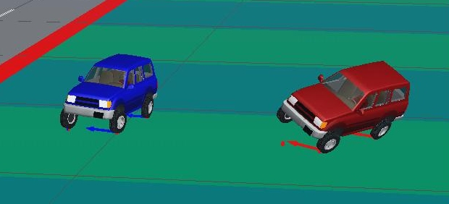
ARM OFF
ARM ON
  - Active Roll Mitigation Control is an active safety system.
  - Detect impending rollover conditions
  - Prevent on-road vehicle roll over situations induced by excessive steering maneuvers.
  - This is done by applying of individual brakes and engine intervention
Figure6. Comparison with or without ARM

Control Strategy
Main goal of ARM function is to prevent vehicle rollover. ARM algorithm evaluates the vehicle
conditions, determines whether an impending rollover condition exists, and determines
whether to intervene. When ARM activates, it provide pressure and slip commands to the
appropriate wheels in an attempt to prevent rollover by reducing the vehicle speed and
energy.

This Fig. 7, shows the high level signal flow and system architecture environment
of ARM in the Electronic Stability Control (ESC).
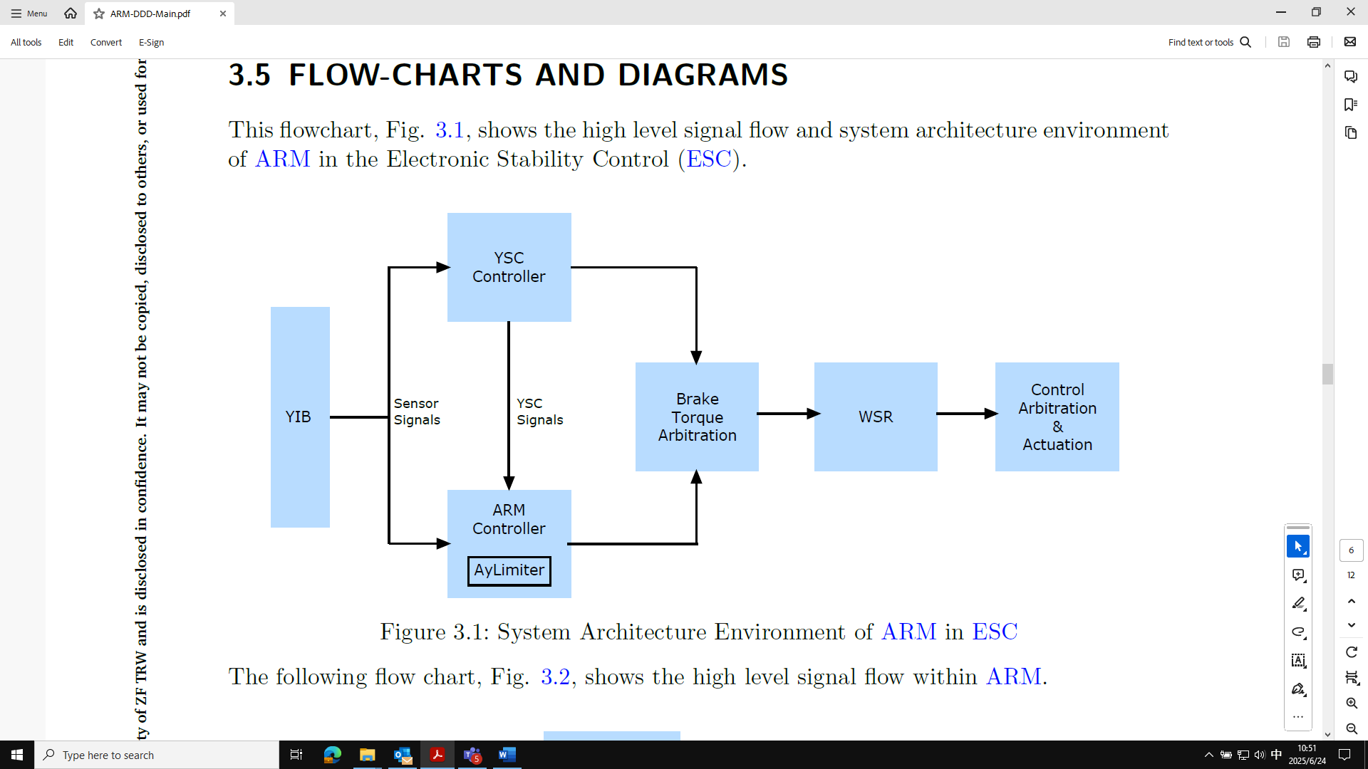
Figure 7. System Architecture Environment of ARM in ESC

In ARM system, ARM is designed to reduce roll instability due to fast steering input: fishhook,
double lane change, etc. Ay Limiter (Control Algorithm that limit the Lateral Acceleration of the
Vehicle) is designed reduce roll instability due slow steering input: constant radius, reducing
radius, etc.
- ARM and Ay Limiter commands are arbitrated inside the ARM module
  - ARM has higher priority than Ay Limiter
- The ARM output commands are passed to the ESC module
- The Arbitrator selects whether ARM or ESC is given control
  - Control is given to the system with the larger control request
  - Brake Pressure and Wheel Slip are considered
- Wheel slip is managed by the ESC wheel slip regulator (WSR) for both ARM and ESC

Test Maneuvers
Sine with D-well, fishhook, double line change are applicable for ARM validation. The test should consider the vehicle’s weight or load changes.

Special States Detect

Specific driving scenarios detection
The ESC function detects special scenarios such as banked bend, trailers, and lane changes,
and proactively desensitize the US and OS threshold calculations.

Performance Mode （CEA2.0 requires）
ESC can change calibrations when the driver selects a different vehicle mode (tour, sport, etc.).
These changes can help change the performance character of the vehicle.
The details will be defined in CEA2.0 performance mode requirement.

Functional safety

Hazard and Risk analysis
This part will be detailed in HARA. Refer to the HARA documents provided by VW.

Functional safety concept
This part will be detailed in FSC. Refer to the FSC documents provided by VW.

Degradation Mode
Refer to the failsafe manual, which defines details and cases. The failsafe manual should be updated during each software release

Regulatory Requirements
The ESC performance should meet the following regional regulatory requirements list in the table.
Region | Document | Title | Version
EU | ECE R140 | Uniform provisions concerning the approval of passenger cars with regard to Electronic Stability Control (ESC) Systems
CN | GB/T30677 | Performance requirements and testing methods for electronic stability control system (ESC) for light vehicles
North America | FMVSS 126 | Electronic stability control systems for light vehicles

Function Dependencies
External systems | Description | Responsible
LDCU | Vehicle Info | LDCU
IMU | Accelaration and Yaw Single | EK
EPS | Steering ability | EF
Foundation Braking | Calipers, discs, tubing | EF

Internal
N/A

Extra

ESC With HMI：
The function at active or fault information of ESC needs to be displayed by HMI in a timely and
correct manner. The function disable or enable by switch signal sending by HMI via CAN bus.

ESC Switch Strategy: One virtual switch proposal (sharing with TCS).
- This solution is used for customer vehicle with only one switch signal for ESC (&TCS) OFF, in this case, when switch off, TCS&ESC function are disabled, then switch on, TCS&ESC function are enabled again.
- No remember function, ESC always be enabled for every wake up
- When the driver's side door is opened and TCS&ESC is switched OFF, iBRS shall enable TCS and ESC functions

ESC torque response requirements
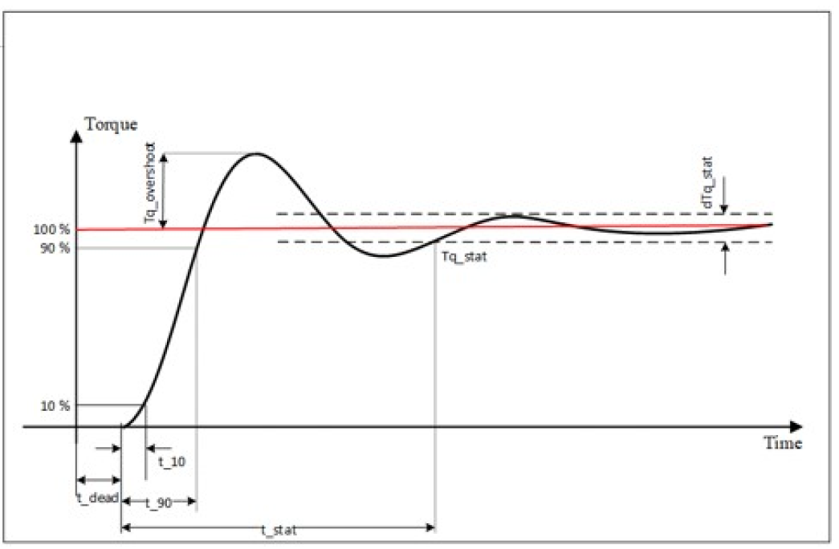
The torque response time requirement to powertrain, should meet the below target:
- Steady response time（t_dead+t_stat):
1) EV Mode ＜ 60ms
2) ICE Mode ＜ 80ms
- Torque overshoot:
Tq_overshoot ＜10%（above 150NM）
Tq_overshoot ＜5% (below 150NM)

Sensor Zeroing
Yaw Rate, SWA, Lat Accel, MCP, Long Accel all dynamically “zeroed”. Zeroing communicates
zeroing status to the ESC controller, gains and deadbands adjusted accordingly

8.3 Self-checking strategy
After KL15 on, the system will send the default value until self check complete. The HMI will illuminate the lamps and keep on 3s.

8.3.1 Function OFF/Active Display Strategy
Name | Symbol | KL15 Status | HMI Strategy
ESC Active Lamp |  | ON | -与TCS Active Lamp共用  仪表显示策略：  如 果 收 到（IPB_ESPFault = 0x0:NotFault且IPB_VDCActSt=0x1:active）或（IPB_ESPFault = 0x0:Not Fault且IPB_TCSActSt = 0x1:active），则指示灯按 2Hz 频率进行闪烁。  异常处理：  如果收不到IPB_VDCActSt或IPB_TCSActSt 信号(按通用策略 10 帧认为丢失)，则认为Not active。  备注：  N/A
ESC  OFF  Lamp |  | ON | -与TCS OFF Lamp共用  仪表显示策略：  1. 如果收到 IPB_ESPPATA ≠ 0x2:off，不点亮指示灯；  2. 如果收到 IPB_ESPPATA = 0x2:off，点亮指示灯。  异常处理：  如果收不到 IPB_ESPPATA信号, 按通用策略 10帧认为丢失，点亮指示灯。  备注：  N/A

8.3.2 Fault Display Strategy
Name | Symbol | KL15 Status | HMI Strategy
ESC  Fault  Lamp |  | ON | -与ESC fault Lamp共用  仪表显示策略：  1. 如果收到 IPB_ESPFault = 0x0:Notfault，不点亮指示灯。  2. 如果收到 IPB_ESPFault = 0x1:Fault，点亮指示灯；  异常处理：  如果收不到 IPB_ESPFault信号1 按通用策略10 帧认为丢失,点亮指示灯。  备注：  N/A

Special Performance Requirements
- This part is defined in VW《ESC Performance Acceptance Specification》

Appendix A

Change History
Version | Change Content | Date（D/M/Y） | Reviewer
V1.0 | Initial edition | 7/9/2025 | Wen Yongzhe

